- 结合EL/JSTL实现对学生基本信息的CRUD操作
代码：AddUserServlet.java
package servlet;

import java.io.IOException;
import java.util.Map;

import javax.servlet.ServletException;
import javax.servlet.annotation.WebServlet;
import javax.servlet.http.HttpServlet;
import javax.servlet.http.HttpServletRequest;
import javax.servlet.http.HttpServletResponse;

import bean.UserBean;

/**
* Servlet implementation class AddUserServlet
*/
@WebServlet("/AddUserServlet")
public class AddUserServlet extends HttpServlet {
private static final long serialVersionUID = 1L;

/**
* @see HttpServlet#HttpServlet()
*/
public AddUserServlet() {
super();
// TODO Auto-generated constructor stub
}

/**
* @see HttpServlet#doGet(HttpServletRequest request, HttpServletResponse response)
*/
protected void doGet(HttpServletRequest request, HttpServletResponse response) throws ServletException, IOException {
request.setCharacterEncoding("utf-8");
response.setCharacterEncoding("utf-8");

UserBean newuser=new UserBean();
newuser.setUserid(request.getParameter("userid"));
newuser.setUsername(request.getParameter("username"));
newuser.setSex(request.getParameter("sex"));
String age=request.getParameter("age");
if(age.equals("")) age=null;
newuser.setAge(age);
newuser.setBirthday(request.getParameter("birthday"));
newuser.setPassword(request.getParameter("password"));
newuser.setConfirmpassword(request.getParameter("confirmpassword"));

Map<String, String> errors=null;
try{
errors=newuser.checkUser();
if(errors.size()==0) newuser.addUser();
}catch(Exception e){
errors.put("othererr", "增加失败："+e.getMessage());
}
if(errors.size()!=0){
request.setAttribute("errors", errors);
request.getRequestDispatcher("/user/AddUser.jsp").forward(request, response);
}else{
request.getRequestDispatcher("/user/MagUser.jsp").forward(request, response);
}
}
/**
* @see HttpServlet#doPost(HttpServletRequest request, HttpServletResponse response)
*/
protected void doPost(HttpServletRequest request, HttpServletResponse response) throws ServletException, IOException {
// TODO Auto-generated method stub
doGet(request, response);
}}
DeleteUserServlet.java
package servlet;

import java.io.IOException;
import javax.servlet.ServletException;
import javax.servlet.annotation.WebServlet;
import javax.servlet.http.HttpServlet;
import javax.servlet.http.HttpServletRequest;
import javax.servlet.http.HttpServletResponse;

import bean.UserBean;

/**
* Servlet implementation class DeleteUserServlet
*/
@WebServlet("/DeleteUserServlet")
public class DeleteUserServlet extends HttpServlet {
private static final long serialVersionUID = 1L;

/**
* @see HttpServlet#HttpServlet()
*/
public DeleteUserServlet() {
super();
// TODO Auto-generated constructor stub
}

/**
* @see HttpServlet#doGet(HttpServletRequest request, HttpServletResponse response)
*/
protected void doGet(HttpServletRequest request, HttpServletResponse response) throws ServletException, IOException {
request.setCharacterEncoding("utf-8");

String userid=request.getParameter("userid");
String error="";
try{
UserBean userbean=new UserBean();
userbean.setUserid(userid);
userbean.delUserById();
}catch(Exception e){
error="删除[userid:"+userid+"]出错："+e.getMessage();
}
request.setAttribute("error", error);
request.getRequestDispatcher("/GetUsersServlet").forward(request,response);
}

/**
* @see HttpServlet#doPost(HttpServletRequest request, HttpServletResponse response)
*/
protected void doPost(HttpServletRequest request, HttpServletResponse response) throws ServletException, IOException {
// TODO Auto-generated method stub
doGet(request, response);
}}
GetUsersServlet.java
package servlet;

import java.io.IOException;
import java.util.List;

import javax.servlet.ServletException;
import javax.servlet.annotation.WebServlet;
import javax.servlet.http.HttpServlet;
import javax.servlet.http.HttpServletRequest;
import javax.servlet.http.HttpServletResponse;

import bean.UserBean;
import bpo.UserBpo;

/**
* Servlet implementation class GetUsersServlet
*/
@WebServlet("/GetUsersServlet")
public class GetUsersServlet extends HttpServlet {
private static final long serialVersionUID = 1L;

/**
* @see HttpServlet#HttpServlet()
*/
public GetUsersServlet() {
super();
// TODO Auto-generated constructor stub
}

/**
* @see HttpServlet#doGet(HttpServletRequest request, HttpServletResponse response)
*/
protected void doGet(HttpServletRequest request, HttpServletResponse response) throws ServletException, IOException {
request.setCharacterEncoding("utf-8");
response.setCharacterEncoding("utf-8");

String username=request.getParameter("username");
String sex=request.getParameter("sex");
String error="";
List<UserBean> users=null;
try{
UserBpo userbpo=new UserBpo();
users=userbpo.getUsers(username, sex);
}catch(Exception e){
error="查询用户出错："+e.getMessage();
}

request.setAttribute("error", error);
request.setAttribute("users", users);
request.getRequestDispatcher("/user/MagUser.jsp").forward(request,response);
}

/**
* @see HttpServlet#doPost(HttpServletRequest request, HttpServletResponse response)
*/
protected void doPost(HttpServletRequest request, HttpServletResponse response) throws ServletException, IOException {
// TODO Auto-generated method stub
doGet(request, response);
}}
UpdateUserServlet.java
package servlet;

import java.io.IOException;
import java.util.HashMap;
import java.util.Map;

import javax.servlet.ServletException;
import javax.servlet.annotation.WebServlet;
import javax.servlet.http.HttpServlet;
import javax.servlet.http.HttpServletRequest;
import javax.servlet.http.HttpServletResponse;

import bean.UserBean;

/**
* Servlet implementation class UpdateUserServlet
*/
@WebServlet("/UpdateUserServlet")
public class UpdateUserServlet extends HttpServlet {
private static final long serialVersionUID = 1L;

/**
* @see HttpServlet#HttpServlet()
*/
public UpdateUserServlet() {
super();
// TODO Auto-generated constructor stub
}

/**
* @see HttpServlet#doGet(HttpServletRequest request, HttpServletResponse response)
*/
protected void doGet(HttpServletRequest request, HttpServletResponse response) throws ServletException, IOException {
request.setCharacterEncoding("utf-8");
UserBean user=this.getUserFromRequest(request);
Map<String,String> errors=this.valid(user);
try {
user.updateUser();
} catch (Exception e) {
errors.put("othererr", "更新数据失败："+e.getMessage());
}
if(errors.size()!=0){
request.setAttribute("errors", errors);
request.setAttribute("updateuser", user);
request.getRequestDispatcher("/user/UpdateUser.jsp").forward(request, response);
}else{
response.sendRedirect(request.getContextPath()+"/user/MagUser.jsp");
}
}

private Map<String,String> valid(UserBean user){
Map<String,String> errors=new HashMap<String,String>();
if(user.getUsername().equals("")) errors.put("username", "用户名不能为空！");
return errors;
}
private UserBean getUserFromRequest(HttpServletRequest request){
String userid=request.getParameter("userid");
String username=request.getParameter("username");
String sex=request.getParameter("sex");
String age=request.getParameter("age");
String birthday=request.getParameter("birthday");

UserBean user=new UserBean();
user.setUserid(userid);
user.setUsername(username);
user.setSex(sex);
user.setAge(age);
user.setBirthday(birthday);

return user;
}
protected void doPost(HttpServletRequest request, HttpServletResponse response) throws ServletException, IOException {
doGet(request,response);
}}
增：
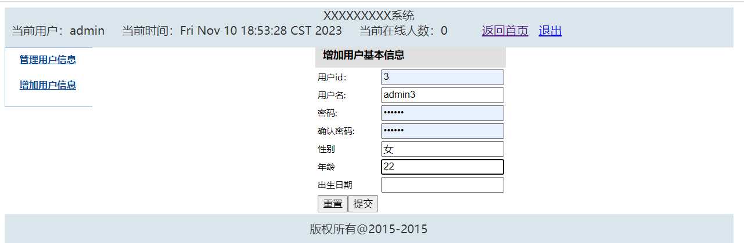
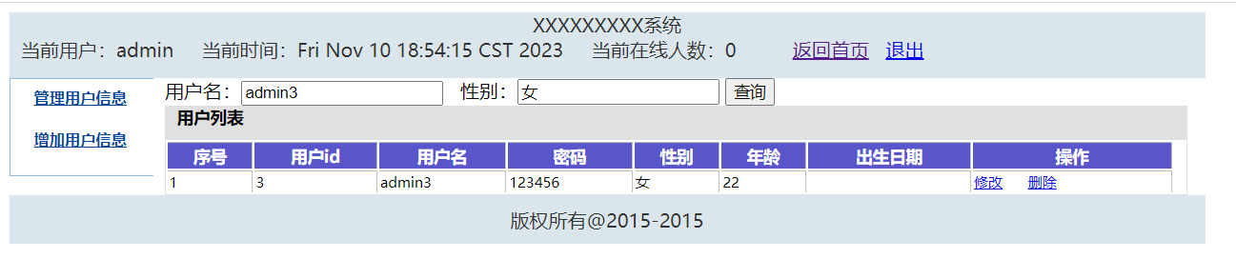
删：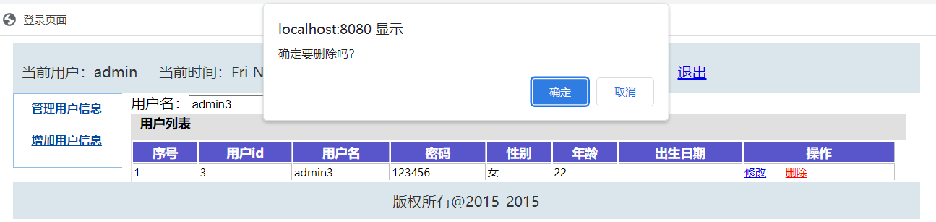
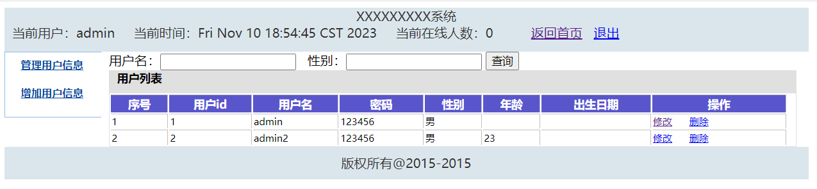
改：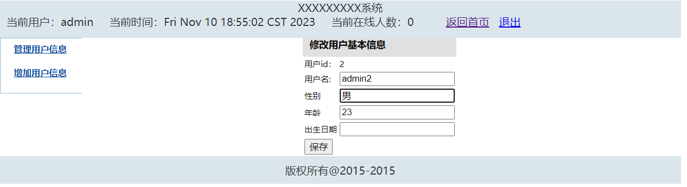
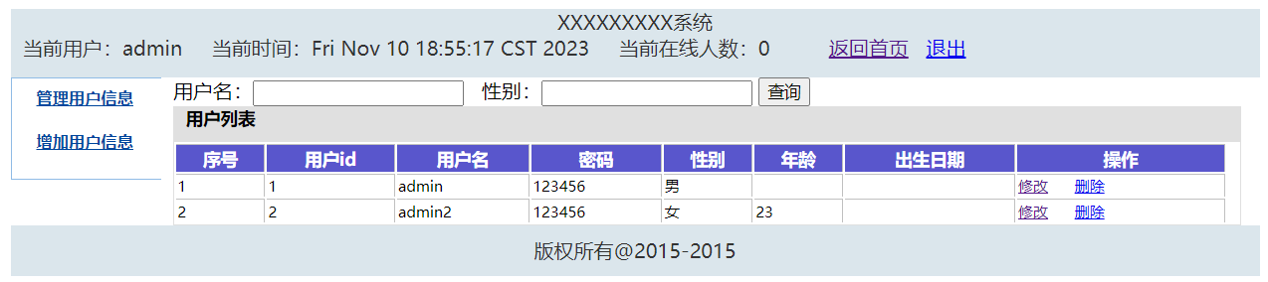
查：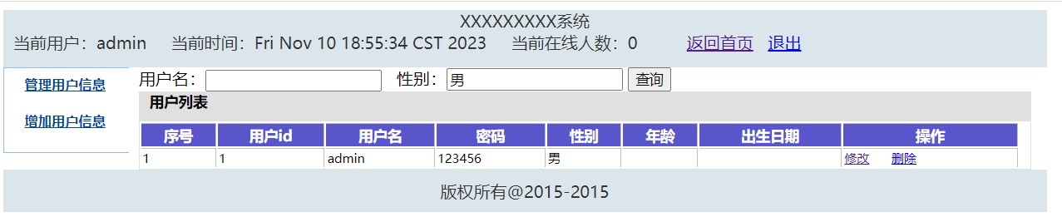

- 整合字符编码和用户登录校验过滤器，以及统计在线人数监听器
整合字符编码代码：package filter;

import java.io.IOException;
import javax.servlet.Filter;
import javax.servlet.FilterChain;
import javax.servlet.FilterConfig;
import javax.servlet.ServletException;
import javax.servlet.ServletRequest;
import javax.servlet.ServletResponse;
import javax.servlet.annotation.WebFilter;

/**
* Servlet Filter implementation class CharEncodingFilter
*/
@WebFilter(filterName="/CharEncodingFilter",urlPatterns="/*")
public class CharEncodingFilter implements Filter {

/**
* Default constructor.
*/
public CharEncodingFilter() {
// TODO Auto-generated constructor stub
}

/**
* @see Filter#destroy()
*/
public void destroy() {
// System.out.println("CharEncodingFilter被销毁");
}

/**
* @see Filter#doFilter(ServletRequest, ServletResponse, FilterChain)
*/
public void doFilter(ServletRequest request, ServletResponse response, FilterChain chain) throws IOException, ServletException {
// System.out.println("CharEncodingFilter开始");
request.setCharacterEncoding("utf-8");

chain.doFilter(request, response);

response.setCharacterEncoding("utf-8");
// System.out.println("CharEncodingFilter结束");
}

/**
* @see Filter#init(FilterConfig)
*/
public void init(FilterConfig fConfig) throws ServletException {
// System.out.println("CharEncodingFilter被调用");
}}
用户登录校验器代码：
package filter;

import java.io.IOException;
import javax.servlet.Filter;
import javax.servlet.FilterChain;
import javax.servlet.FilterConfig;
import javax.servlet.ServletException;
import javax.servlet.ServletRequest;
import javax.servlet.ServletResponse;
import javax.servlet.annotation.WebFilter;
import javax.servlet.http.HttpServletRequest;
import javax.servlet.http.HttpServletResponse;

/**
* Servlet Filter implementation class LoginFilter
*/
@WebFilter(filterName="/LoginFilter",urlPatterns="/*")
public class LoginFilter implements Filter {

/**
* Default constructor.
*/
public LoginFilter() {
// TODO Auto-generated constructor stub
}

/**
* @see Filter#destroy()
*/
public void destroy() {
// System.out.println("LoginFilter被销毁");
}

/**
* @see Filter#doFilter(ServletRequest, ServletResponse, FilterChain)
*/
public void doFilter(ServletRequest request, ServletResponse response, FilterChain chain) throws IOException, ServletException {
// System.out.println("LoginFilter开始");
HttpServletRequest hrequest=(HttpServletRequest) request;
HttpServletResponse hresponse = (HttpServletResponse) response;
// 不过滤的uri
String[] notFilter = new String[] {"index.jsp","LoginValidServlet"};
// 请求的uri
String uri = hrequest.getRequestURI();
//不在notFilter中的才过滤，且为servlet和jsp
if(uri.indexOf("Servlet")!=-1||uri.indexOf(".jsp")!=-1){
boolean doFilter = true;// 是否过滤
for (String s : notFilter) {
if (uri.indexOf(s) != -1) {
// 如果uri中包含不过滤的uri，则不进行过滤
doFilter = false;
break;
}
}
if (doFilter) {// 执行过滤
Object obj = hrequest.getSession().getAttribute("user");//从session中获取user对象
if (null == obj ) {
//返回登陆页面
hresponse.sendRedirect(hrequest.getContextPath() + "/index.jsp");
return;
}else{
chain.doFilter(request, response);
}
}else {// 如果不执行过滤，则继续
chain.doFilter(request, response);
}
}else{
chain.doFilter(request, response);
}
// System.out.println("LoginFilter结束");
}

/**
* @see Filter#init(FilterConfig)
*/
public void init(FilterConfig fConfig) throws ServletException {
// System.out.println("LoginFilter被调用");
}}
在线统计人数监听器代码：
package listener;

import javax.servlet.annotation.WebListener;
import javax.servlet.http.HttpSessionEvent;
import javax.servlet.http.HttpSessionListener;

/**
* Application Lifecycle Listener implementation class CounterListener
*
*/
@WebListener
public class CounterListener implements HttpSessionListener {
private int onlineNumber=0;
public void sessionCreated(HttpSessionEvent arg0) {
System.out.println("sessionCreated");
onlineNumber++;
arg0.getSession().getServletContext().setAttribute("onlineNumber",onlineNumber);

}
public void sessionDestroyed(HttpSessionEvent arg0) {
System.out.println("sessionDestroyed");
onlineNumber--;
arg0.getSession().getServletContext().setAttribute("onlineNumber",onlineNumber);
}}

package listener;

import javax.servlet.ServletContextEvent;
import javax.servlet.ServletContextListener;
import javax.servlet.annotation.WebListener;

/**
* Application Lifecycle Listener implementation class MyFirstListener1
*
*/
@WebListener
public class MyFirstListener implements ServletContextListener {
public void contextInitialized(ServletContextEvent sce) {
//获取web.xml中配置的属性
String value=sce.getServletContext().getInitParameter("projectName");
System.out.println(value);
}
public void contextDestroyed(ServletContextEvent sce) {
// TODO Auto-generated method stub
}}
用户人数在线实现截图：
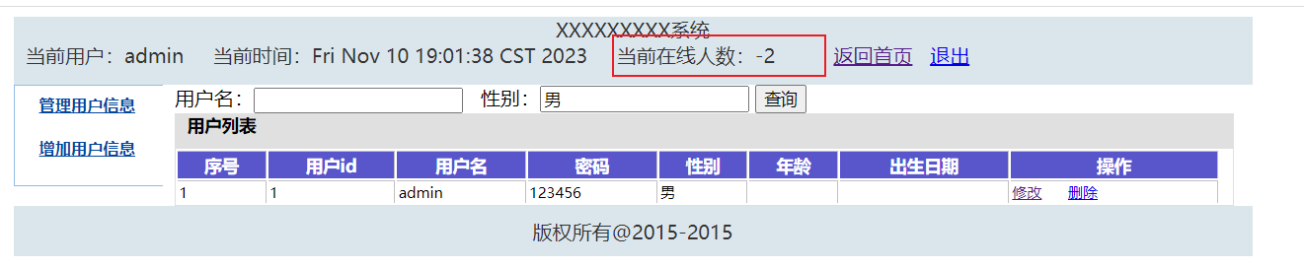

LoginCheck.jsp
<%
request.setCharacterEncoding("utf-8");
response.setCharacterEncoding("utf-8");
%>
<c:if test="${empty user.username}" var="username">
<c:redirect url="/index.jsp"/>
</c:if>

